# SC2006 Group Sinister Six Lab 1

**Mission Statement**

The Fantastic Four team will develop a website that enables apartment owners and potential apartment buyers in Singapore to look at current prices in their town or town. The website will provide a predictive algorithm looking one year into the future of how the prices might develop and therefore help the owners/buyers to make an informed decision. The project is complete when it has been tested and approved by the project team.

**Target Users**

* Owners of Singapore apartments
* Potential buyers of Singapore apartments
* Administrator

In this document the owners and potential buyers will be addressed as users.

**1 Functional Requirements**

1.1 When a user connects to the webpage it will display a map of Singapore split into the different towns.

1.1.1 The user has to be able to click on any of these towns and show a current mean price of the all apartments in that town.

1.1.1.1 When a town is selected a graph should be displayed showing the development of the prices. It should show at least 24 month in the past.

1.1.1.2 The detailed view of a town should also show a prediction of how the prices might develop over the next 12 months.

1.1.2 The user has to be able to select multiple towns in order to compare their current pricing next to each other.

1.2 There must be a search function displayed on the map for the user to use.

1.2.1 The search function must contain the following fields: town, room number, floor area, flat model, lease commence date

1.2.1.1 The town must be a text field with less than 512 characters, and an autofill dropdown selection. It can be empty.

1.2.1.2 The room number must be a full number greater than 0 and smaller than 10.

1.2.1.3 The floor area is a full number defined in square meters, it must be greater than 0 and smaller than 500.

1.2.1.4 The flat model must be a text field with at least one character and less than 512, and an autofill dropdown selection.

1.2.1.5 The lease commence date must be a year, greater than current year minus 100 and equal or smaller than the current year.

1.2.2 The search results must contain a filter and sorting function.

1.2.2.1 The filter and sorting function must be able to filter and sort according to the following fields: town, room number, floor area, flat model, lease commence date, price

1.3 The users must have a function to fill in a feedback form or contact the support staff / administrator.

1.4 The administrator must be able to access the backsystem in order to perform maintenance

**2 Non-Functional Requirements**

2.1 The system should display all text in english.

2.2 When a search action is performed, the results must be provided within 5 seconds.

2.3 Previous searches of a user should be saved in the browser cache.

**3 Out of Scope**

3.1 There will be no function to create a user account.

**Use Case Diagram**

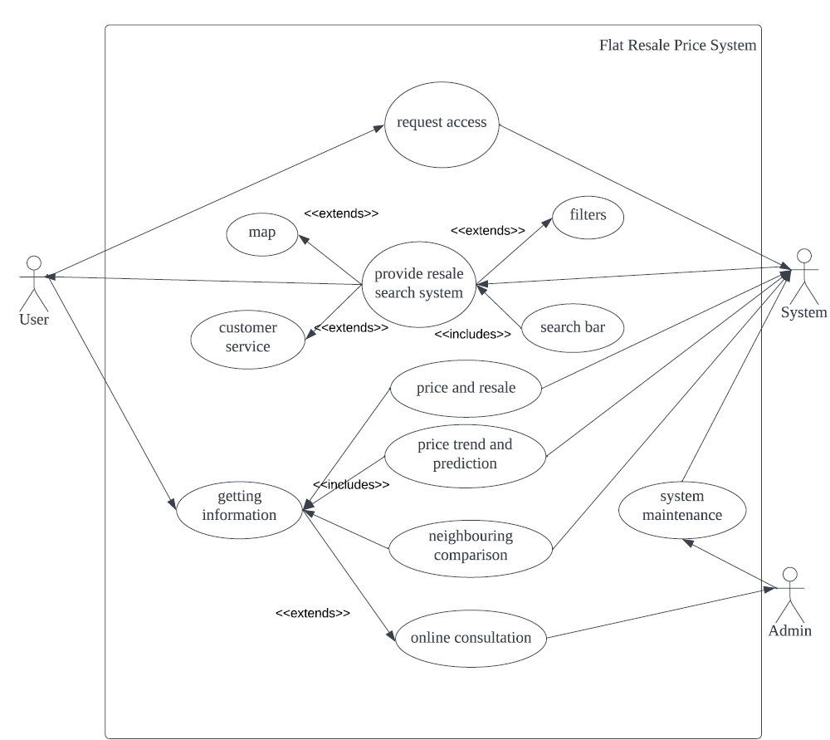

**Use Case Description**

|  |  |  |  |
| --- | --- | --- | --- |
| Use Case ID: | FF01 | | |
| Use Case Name: | Request System Access | | |
| Created By: | Sandro Mero | Last Updated By: | Minjuan Luo |
| Date Created: | 22.08.2022 | Date Last Updated: | 22.08.2022 |
|  |  |  |  |
| Actor: | User (potential buyer or seller), System | | |
| Description: | The use case that shows the user requesting access to the system | | |
| Preconditions: | User must have a computer device and Internet connection. | | |
| Postconditions: | The System must allow the user to access the service. | | |
| Priority: | High | | |
| Frequency of Use: | Multiple times a day | | |
| Flow of Events: | 1. The user opens any internet browser in his computer device.  2. The user enters the URL of the Service  3. The internet browser sends an access request to the service.  4. The system of the service will check the request and allow it.  5. The service sends required information to the browser on the users device  6. The browser displays the webpage. | | |
| Alternative Flows: | AF-S2: The user does not know the URL  1. The user searches for the service through a search engine.  2. The search engine provides a link to the URL of this webpage  3. Continue with step 3. | | |
| Exceptions: | EX1: If the browser can not reach the service  1. The browser will display an error message "The service is temporarily not available, please  try at a later time."  EX2: Access to the service has been denied  1. The browser will display an error message: "Access Denied. Please contact an  administrator." | | |
| Includes: | - | | |
| Special Requirements: | - | | |
| Assumption: | - | | |
| Notes and Issues: | - | | |
| Use Case ID: | FF03 | | |
| Use Case Name: | Provide resale information | | |
| Created By: | Sandro Mero | Last Updated By: | Minjuan Luo |
| Date Created: | 22.08.2022 | Date Last Updated: | 22.08.2022 |
|  |  |  |  |
| Actor: | User (potential buyer or seller), System | | |
| Description: | The use case that describes the user getting resale information from the system | | |
| Preconditions: | The user must get the access to the resale system and have no internet faliure | | |
| Postconditions: | The resale system must show relevant information within seconds | | |
| Priority: | Very High | | |
| Frequency of Use: | Multiple times a day | | |
| Flow of Events: | 1. The user input the region of the house/flat that he want to look for  2. The user input the budget range of the house/flat that he want to look for  3. The user input the time range of the resale price that he want to look for (not necessary)  4. The internet server sends a request to the system  5. The system sends back the results to the internet server  6. The server display messages in a new web page | | |
| Alternative Flows: | AF-S2: The user don't know how to use the system  1. The user look for the online consultation button in the web page  2. The resale system provide a chatbox for the user to contact administrator  3. The administrator give suggestions to the user | | |
| Exceptions: | 1. The system don't recognize the region that the user is looking for and send back messages to ask for  another attempt  2. The system don't have the information that the user is looking for and send back an apologize  3. The server have an internet faliure and send back the error message to the user | | |
| Includes: | maps, filters, search bar and customer service | | |
| Special Requirements: | NULL | | |
| Assumption: | The system may crash and fail to operate | | |
| Notes and Issues: | The system may not have enough vacancy for a large amount of access | | |
| Use Case ID: | FF02 | | |
| Use Case Name: | System maintenance | | |
| Created By: | Sandro Mero | Last Updated By: | Minjuan Luo |
| Date Created: | 22.08.2022 | Date Last Updated: | 22.08.2022 |
|  |  |  |  |
| Actor: | Administrator, System | | |
| Description: | The use case that shows the admin may fix the system problems when there is a crash | | |
| Preconditions: | The system was crashed or the admin check the system once a week | | |
| Postconditions: | The system is fully prepared for next week's operation | | |
| Priority: | Extremely High/Median | | |
| Frequency of Use: | Once a week | | |
| Flow of Events: | 1. The system was crashed due to unknown reason and require maintenance ASAP  2. The admin check the system once a week  3. The system was fully checked and fixed by the admin  4. The system back to normal situation | | |
| Alternative Flows: | NULL | | |
| Exceptions: | The admin is unable to fix the system and require further help | | |
| Includes: | NULL | | |
| Special Requirements: | The admin is well experienced in system maintenance | | |
| Assumption: | The system may not be able to operate because of some physical damage | | |
| Notes and Issues: | The physical system maintenance may require a large amount of time and component replacement | | |

**Data Dictionary**

|  |  |
| --- | --- |
| **Term** | **Definition** |
| Administrator | A person who ensures a safe and efficient user experience. |
| Algorithm | A process or set of rules to be followed in calculations or other problem-solving operations |
| Backsystem | The code that runs on the server, that receives requests from the clients, and contains the logic to send the appropriate data back to the client |
| Buyer | A person who makes a purchase with the intention of making a profit. |
| Cache | A hardware or software component that stores data so that future requests for that data can be served faster |
| Consultation | A meeting session with the objective of providing advice to buyers. |
| Comparison | The act of examining prices in a competitive manner, to see if they are similar or different |
| Customer | A person who purchases a flat for private utilization. |
| Filter | A piece of software that processes data before passing it to another application, to remove unwanted results. |
| Graph | A diagram showing the relation between variable quantities, typically of two variables, each measured along one of a pair of axes at right angles. |
| Mean | The average of a data set is found by adding all numbers in the data set and then dividing by the number of values in the set. |
| Maintenance | System software upgrades, repairs, patches or configuration changes. |
| Neighbourhood | A district or community within Singapore |
| Owner | A person who has the legal or rightful title to the flat. |
| Prediction System | Estimation of some variable of interest at some specified future date. |
| Resale Flat | Flats that are currently owned by someone else. |
| Search Time | The amount of time taken by an algorithm to run, as a function of the length of the input. |
| Search Bar | A single-line text box with the dedicated function of accepting user input to be searched for in a database. |
| System | A group of related hardware units or programs or both, especially when dedicated to a single application. |
| Town | The central part of a neighbourhood, with its business or shopping area. |
| User | Terminology for owners and potential buyers. |

Dataset:

<https://data.gov.sg/dataset/resale-flat-prices?resource_id=1b702208-44bf-4829-b620-4615ee19b57c>